A222-Afr-Egy-Tutankamun-Chair

 

Fig. 1. Tutankhamun’s “Throne.” Miniature replica

Fig. 2. Tutankhamun’s “Throne.” Original in the Egyptian Museum, Cairo. From http://www.touregypt.net/images/touregypt/tutl57.jpg

**Case No.: 2**

**Formal Label:** Tutankhamun’s “Throne.”

**Display Description**:

Note. The Throne. “The suggestion that the gold inlaid chair was indeed nothing less than a throne is necessarily only hypothetical. There is nothing on the chair itself to tell us definitely. But judging from the extreme richness of its appearance when compared with the other chairs found in this tomb, as well as those of former discoveries, its very ornate almost florid decoration, which has been carried far, even to the detriment of comfort, shows it to be on an entirely different and higher level than the rest. In fact it seems appropriate only to a chair of state for a sovereign.” From Howard Carter’s Notebook, [TAA i.2.10.25](http://www.griffith.ox.ac.uk/gri/tut-scans/TAA_i_2_10_25.jpg), p. 3

**Accession Number: A222**

**LC Classification:** DT87.5

**Date or Time Horizon:** reign of Tutankhamun (1332-1323 BCE)

**Geographical Area: Luxor**

**LC Classification:** DT62

**Date or Time Horizon:** New Kingdom Period-18th dynasty (1549/1550-1292 BCE)

**Geographical Area: KV62 Valley of the Kings**

**Map, GPS Coordinates:** 25.74036 32.60141; 25º44'25.29" N 32º36'5.06" E

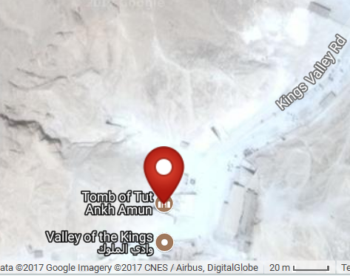

**Cultural Affiliation:** New Kingdom Period

**Medium:** brass

**Dimensions: replica: 174.92 mm; 6.887 in  
Weight: n/a**

**Provenance: Egyptian Museum, Cairo**

**Condition: replica**

**Discussion: “**The Aten form of the King's name which it bears together with certain indubitable ancient repairs, even palimpsests, clearly prove that it was made for a much earlier use than for mere sepulchral purposes. Again it is far too ornate for general everyday house use, which also suggests it was made for a special purpose.” From Howard Carter’s Notebook, [TAA i.2.10.25](http://www.griffith.ox.ac.uk/gri/tut-scans/TAA_i_2_10_25.jpg), p. 3

**References:**

Howard Carter’s Notebook, [TAA i.2.10.25](http://www.griffith.ox.ac.uk/gri/tut-scans/TAA_i_2_10_25.jpg)